Krushi Sahyog: Plant disease identification and Crop recommendation using Artificial Intelligence
Alternate Title: Crop recommendation and plant leaf identification using machine and deep learning technique.
Aim:
To detect the plant leaf disease and to recommend the crop using Machine and Deep learning.
Abstract:

India is one of the leading countries worldwide in terms of farm output. Even after being a leading producer of agricultural products, India still lacks farm productivity. Farmers have very less income because of the lack of farm productivity. Identification of leaf disease is very difficult in agriculture field. If identification is incorrect then there is a huge loss on the production of crop and economical value of market. To increase productivity, farmers should know which crop would suit the specific piece of land. If the right type of crop is cultivated in that piece of land, then automatically, the yield of the crop will increase. Hence, crop recommendation systems can be very beneficial for farmers. We use machine learning algorithm for crop recommendation and deep learning for plant disease identification. Leaf disease detection requires huge amount of work, knowledge in the plant diseases, and require the more processing time. Therefore, we can use image processing for identification of leaf disease. The system has been tested with the different numbers of test data set collected from different regions. We combine the both crop recommendation and plant disease identification. We can able to find the output in the Web-app.

Existing System:
In existing system, they have crop recommendation system and plant disease recommendation system separately. These two projects are in machine learning and deep learning. It hard to use one project for crop prediction and another one for plant disease recommendation. We want to make combine together for user friendly.

Proposed System:
Now a day’s, dilettante farmers are hard to understand the plant disease, cultivation process, crop type, climate change, etc. Farming is that the spine for every nation's economy. Future agriculture depends on dilettante formers. But new farmers not so strong at farming, So Machine learning and deep learning help to solve their problems. We combine plant disease identification and Crop recommendation system in this single project to make it user friendly.
We use machine learning algorithm for crop recommendation. Here we use random forest algorithm. And we use Convolutional neural network for plant disease identification. And we did it by the web app. That was created by flask.

Module Description:

- Dataset collection
- Algorithm Implementation
- Recommendation and Detection

Dataset Collection:
- Crop recommendation:
Our crop prediction project dataset are collected from kaggle.com. Data is preprocessed after collection of various records. Dataset in CSV format
- Plant Disease Identification:
We collect the dataset in the form of image. Dataset has different types of plant disease. We collect this dataset from the Kaggle.com

Implementation:

- Crop recommendation:
The Classification Algorithms to produce the best results. We are using Random Forest Algorithm to predict the crop using ML. On an analysis conducted within various algorithms, the Random Forest was found to provide highest efficiency.
- Plant Disease Identification:
Neural network algorithm is used to give the best results. Here we using deep learning to identify the plant disease prediction. Convolution neural network is a subset of deep learning neural network. It is mainly used for image classification and image analysis. Benefit of CNN’s is that they are easier to train with providing high accuracies.
Recommendation and prediction:
Preprocessed data are trained and input given by the user goes to the trained dataset. And also we can able detect the plant disease by uploading the plant leaf image in Web-app. Using the deep learning method, finally the disease will be labeled which types of disease are affected and it also says the remedy for the leaf disease.
Software Requirements:
- Operating System : Windows 7 , 8, 10 (64 bit)
- Software : Python and Anaconda
- Framework : Flask, HTML
- Database : SQLite

Hardware Requirements:
- Hard Disk : 500GB and Above
- RAM : 4GB and Above
- Processor : I3 and Above

Architecture Diagram:
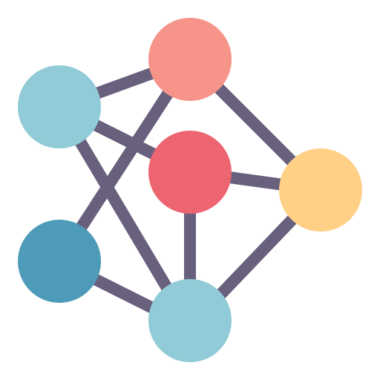
Crop Recommendation
Plant Disease Detection
Dataset
Image Dataset
Preprocessing
Preprocessing
Machine Learning
Deep Learning
Web application
User

